# Lab *XX* – *Title*

**Author**:

**Course Section**:

**Date**:

# **Introduction**

In this lab, I will be able to successfully set up GitHub on my virtual machine. GitHub is a virtual control system that tracks changes and allows programmers to coordinate their work during software development. I will also be able to perform some basic operations on GitHub to familiarize myself with the system.

# **Process**

**Step *0*: Signing Up for a GitHub account**

**Breakpoint 0:** This step was very straightforward, but I was asked to verify my student account, so I had to upload an image of my student ID. Other than this, I was able to create an account and locate the settings page for the screenshot.

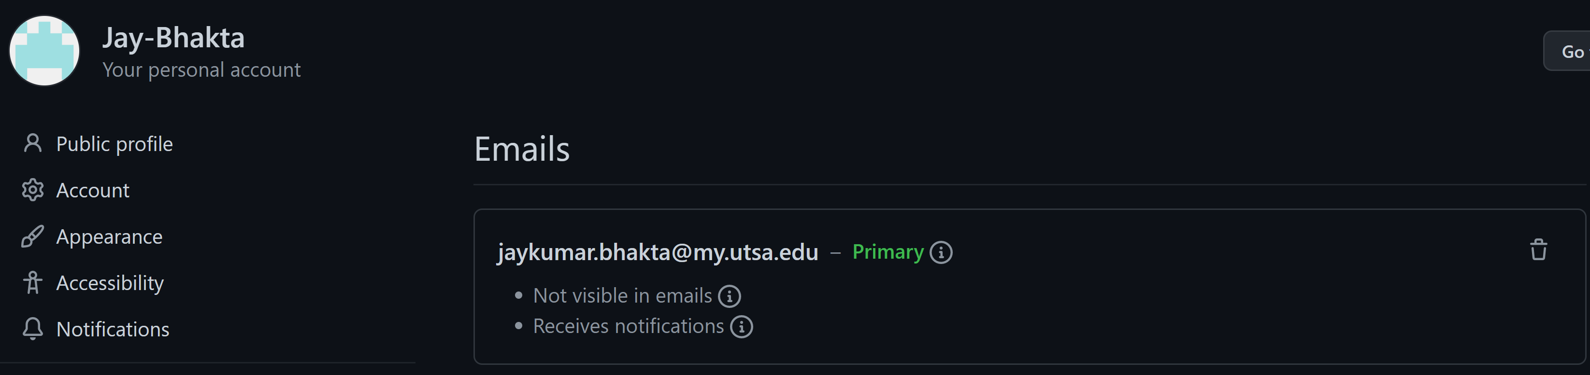

Figure 1: This screenshot depicts my GitHub username and the primary email associated with my account.

**Breakpoint 1:** For this step, I was able to configure my git username and email on my Linux machine terminal.

Figure 2: Configuring my git username and email.

**Breakpoint 2:** In this step, I created a new repository on the GitHub website. I named the repo “IS1003” and made it private according to the instructions.

Figure 3: My repository on GitHub.

**Breakpoint 3: In this step, I started by changing the directory to desktop, then made a subfolder named IS1003-. Next, to create the local repo, I had to create the README.md file. I created the README.md file by redirection. I used echo [Hola] and output it to the README.md file. Next, to initialize the local repo, I used the [git init] command. Next, I added the README.md file to the staging area (a temporary holding place for files) by using the [git add README.md] command. Next, to create an actual version of the repo from all the files in the staging area, I used the [git commit -M “first commit”] command. Finally, to verify the default branch name, I used the [git branch] command then to change the branch name, I used the [git branch -M main] command.**

Figure 4: All the different commands to create a local repo.

Breakpoint 4: To sync the local repo with my remote repo on GitHub, I used the SSH (secure shell protocol) method. With this method, you can use the SSH protocol and SSH keys. With the SSH protocol, you can connect and authenticate to remote servers and services. With the SSH keys, you can connect to GitHub without supplying your username and personal access token every time. Therefore, I was able to generate an SSH key with the [ssh-keygen -t ed25519 -C “jaykumar.bhakta@my.utsa.edu”] command. Next, I verified that the key existed in the .ssh file. Next, I copied the SSH key to add to my GitHub account.

Figure 5: Generating an SSH key.



Figure 6: Verifying that the key exists and copying the key for my GitHub account.

Figure 7: Adding the SSH key to my GitHub account.

**Breakpoint 5:** To sync the repos, I used the link I copied from my GitHub account to use with the [git remote add origin git@github.com<your repo link>] command on my Linux terminal. Then to check my SSH connection, I used the [cd -v] command.

Figure 8: Syncing the SSH connection and checking on the links.

**Breakpoint 6:** This step was a challenge for me because I thought that I did everything correctly, and when I went to type the {git push -u origin main} command, I encountered an error that stated that permission was denied and I had to check if I had access rights. I panicked when that happened and was confused about what I did wrong. I posted on slack to receive help and used what I was informed to fix the error, but the error still showed. The next day I tried again and looked at the tips section on Lab 2, but it didn’t fix anything, so I contacted you (the professor). While I was waiting for a reply, I started over and created a new repo on GitHub and a new file with a different name on my local machine. Then, I followed the instructions and was able to successfully complete step 6. The push command is a command that allows you to depict changes from your local repo files in Linux VM to your GitHub account.

Figure : My work from Step 3.

Figure : My work from Step 5.

Figure : My work for Step 4&5.

Figure : My work from Step 5&6.

**Breakpoint 7:** On GitHub, I clicked the edit icon to delete “hello” and replaced it with “howye doin”. I then to confirm I scrolled down and clicked “Commit changes”.

Figure : My work from step 7.

**Breakpoint 8:** I edited the message that was sent from my local repo on my remote repo. To see the change on my local repo, I need to pull the transition from my remote repo. I do this by using the “git pull origin main.” Then, to see the message, I cat the file so [cat README.md]. The pull command is a command which allows you to depict changes made on your remote repo onto your local repo.

Figure : My work from step 8.

**Breakpoint 9: For this I had to choose a GitHub repo to fork and clone. On GitHub, I clicked on the explore tab then the topics tab. I chose the Algorithm topic because I wanted to see how algorithms are created, what they look like, and what they accomplish. From there, I chose a repo named “interview” because it included a summary of basic characteristics needed for job seeking and technology such as program library, algorithm, system, network, and more. The clone command allows users to work on files locally with whatever software and without impacting their remote repos.**

Figure : My work for the git tasks/output for step 9.

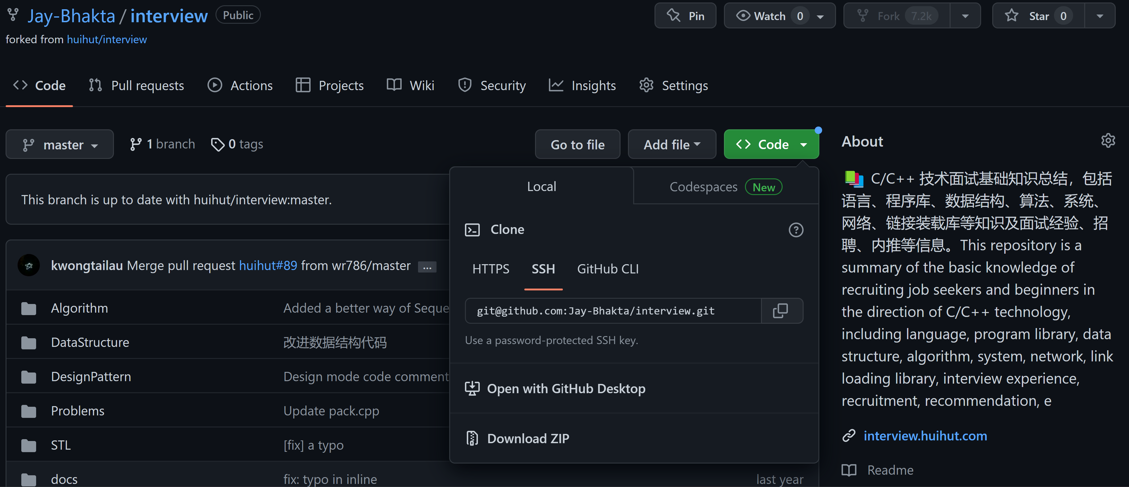

Figure : My work for GitHub in step 9.

# **Limitations/Conclusion**

I was able to complete all the steps in this lab. The objective of this lab was to be able to create a GitHub account, setup a git on our local machines, and synchronize our local repo with out GitHub repo. This lab was like a introduction of what programmers do during software development. And this process is very important not only for software developers but also for information technology professionals that work with evolving technology.

# **References**

# **Collaboration**

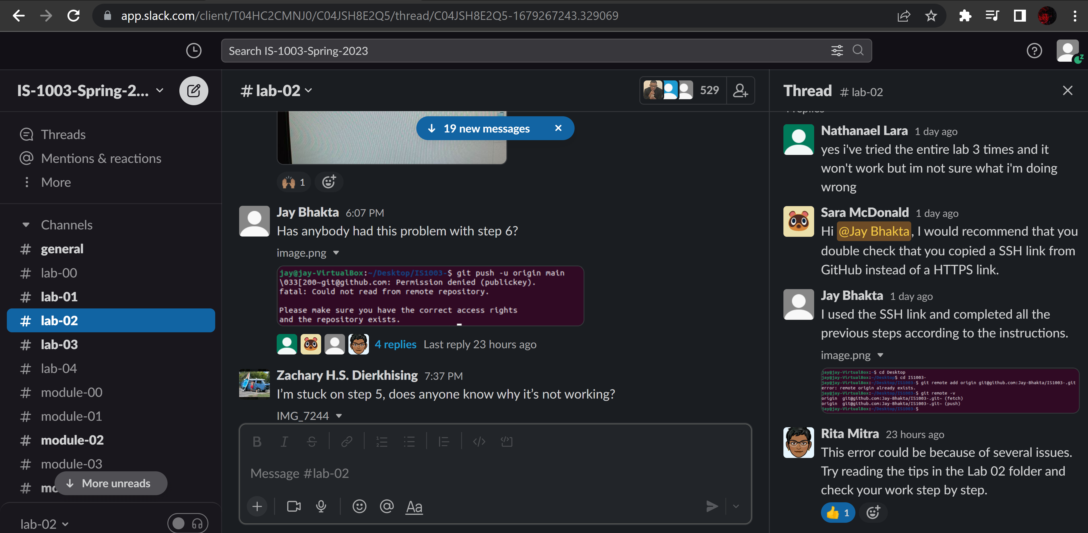

Figure : Proof of collaboration using slack.